

**BIG DATA ANALYTICS LAB**

**WEEK-5**

**NAME :** M.SRIKAR **BRANCH & SEC :** CSD-B

**ROLLNO :** 22R21A67A7 **DATE :** 25-09-24

**PROBLEM STATEMENT:**

Implement Matrix Multiplication on Hadoop using Map reduce

**Source code:**

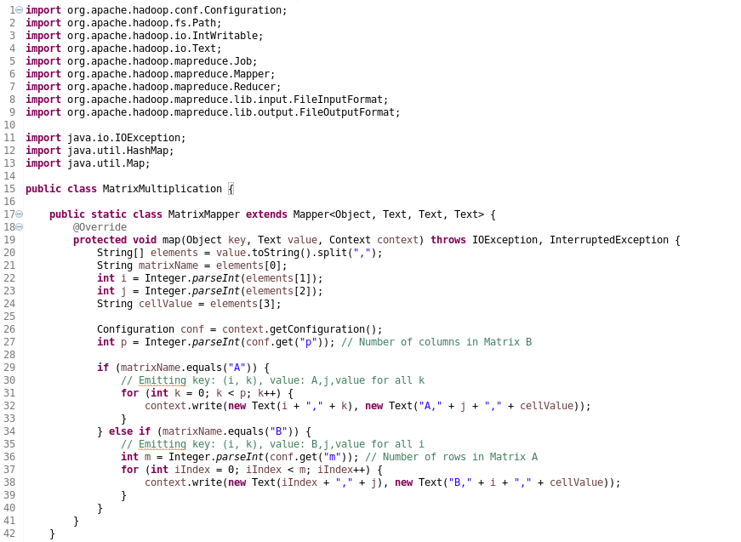

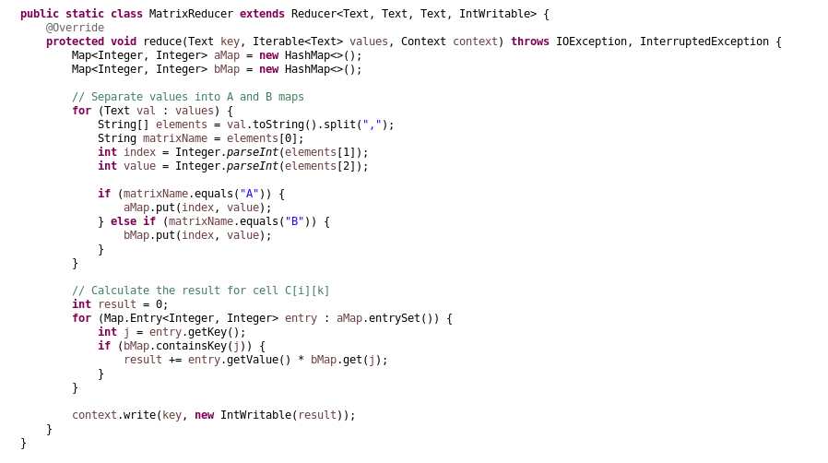

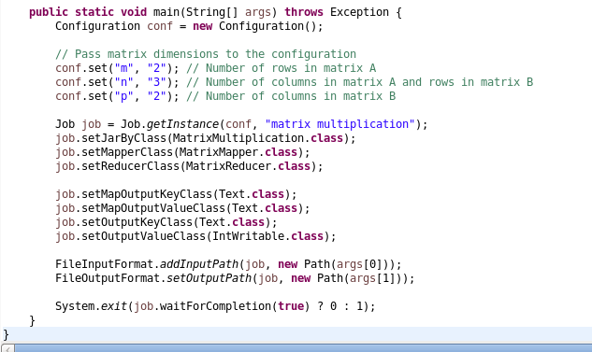

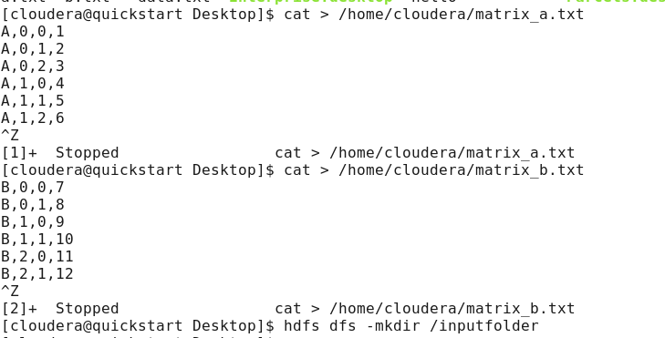



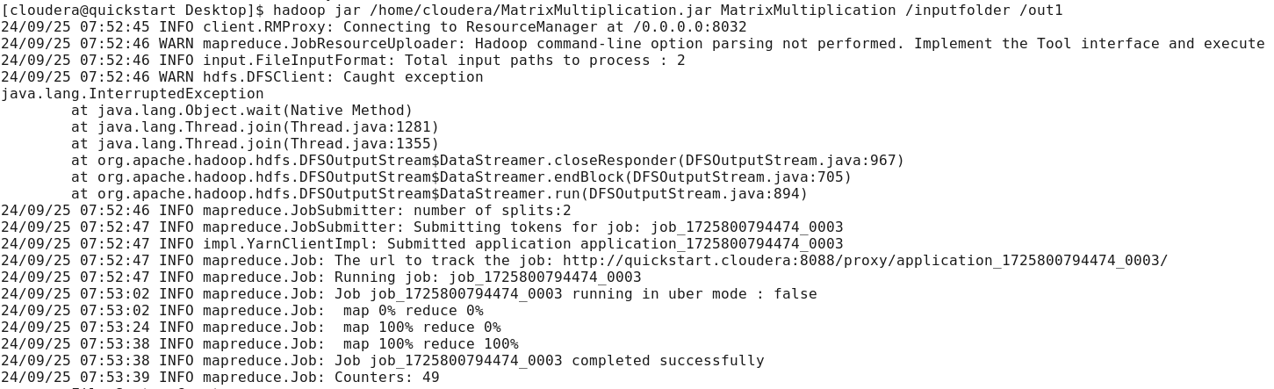

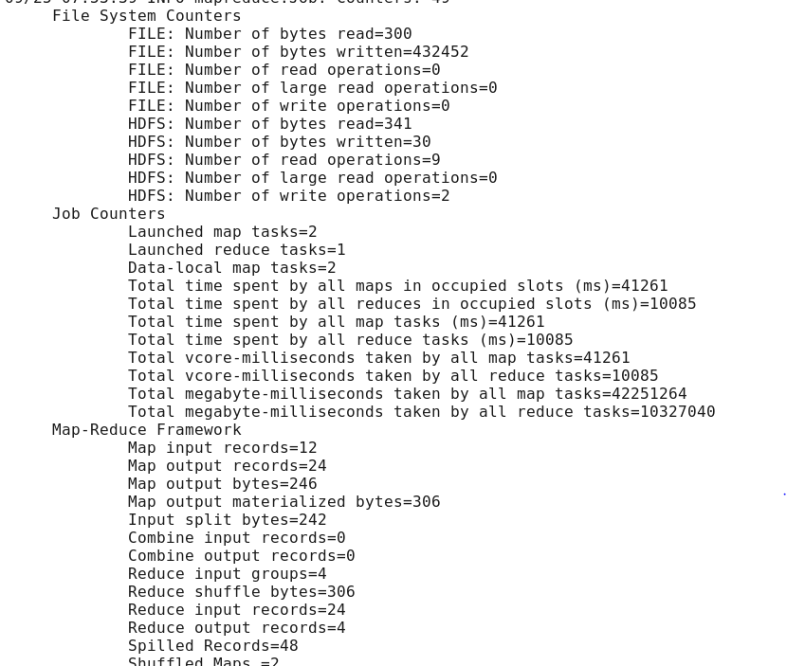

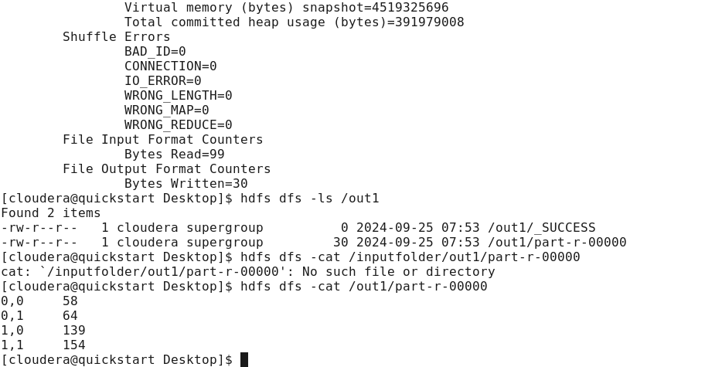

9